Draft Requirements (Must/Should)
- The user must be able to use the accounts feature
  - The user must be able to create, update, and delete an account
  - The user must be able to log into their account
- The user must be able to use the Timers feature
  - The user must be able to use and edit the premade timers
  - The user must be able to create their own timers
  - The timers must be saved onto the user’s account
  - The user must be able to delete any timer on their account (premade or self-made)
- The user must be able to manipulate the calendar feature
  - The users must be able to add, edit, and delete events from the calendar
  - The calendar must show the total hours worked that day, and each study session
    - This must be shown as individual sessions timed either by the in-app timers or by user input
    - Each day will reset at midnight, in a given time-zone. If a session crosses over through midnight the app will record the session on the day the session was started
  - The user could be able to integrate their university timetable with the calendar feature
- The user must be able to collect points
  - The points must be given upon completion of a given task added to the calendar
  - The points gained must increase if a task is completed before the given date
  - No points must be given if a task is not completed by the given date
  - The user must be able to use those points in a cosmetics shop on the app

Stretch Requirements (Could)
- The user could input their deadlines and exam timetables manually or using Canvas
- The user should be able to create a “routine” (combination of timers and timed breaks) which should be saved as one continuous session
  - The session time could include both the time studying and the scheduled break or only count the time studying

Azure VM using Azure Credits:
- If using azure, need a bash script to turn it off at midnight or else I’ll get billed
- Only available for 12 months, no long-term support, no 24/hr support
- Could also host locally (not fully deployed – last resort (also used for demo))

Functional Requirements
Requirement ID: 1.1
Requirement priority: 1
Requirement Description: The user must be able to create an account
Inputs: user email, user password
Outputs: error message, confirmation message, verification email
Persistent Changes: new user account is added to database with provided information
Related Requirements and Use Cases: N/A
Test Cases:

Requirement ID: 1.2
Requirement priority: 4
Requirement Description: The user must be able to verify their account
Inputs: verification code
Outputs: error message, confirmation message
Persistent Changes: user is deemed as ‘verified’ and can then access all features
Related Requirements and Use Cases: 1.1
Test Cases:

Requirement ID: 1.3
Requirement priority: 2
Requirement Description: The user must be able to edit their account details
Inputs: user password, new user email, new user password
Outputs: error message, confirmation message, confirmation email
Persistent Changes: new user details are updated in the database with provided information
Related Requirements and Use Cases: 1.1, 1.2
Test Cases:

Requirement ID: 1.4
Requirement priority: 1
Requirement Description: The user must be able to delete their account
Inputs: user email, user password
Outputs: error message, confirmation message, confirmation email
Persistent Changes: user account is deleted from the database as well as all information connected to account
Related Requirements and Use Cases: 1.1, 1.2
Test Cases:

Requirement ID: 1.5
Requirement priority: 1
Requirement Description: The user must be able to log into their account
Inputs: user email, user password
Outputs: error message, confirmation message
Persistent Changes: no persistent changes
Related Requirements and Use Cases: 1.1, 1.2
Test Cases:

Requirement ID: 2.1
Requirement priority: 2
Requirement Description: The user must be able to create a timer.
Inputs: an amount of time in minutes
Outputs: a new timer with the given time
Persistent Changes: new timer is stored in the database under the user’s account
Related Requirements and Use Cases: N/A
Test Cases:

Personas
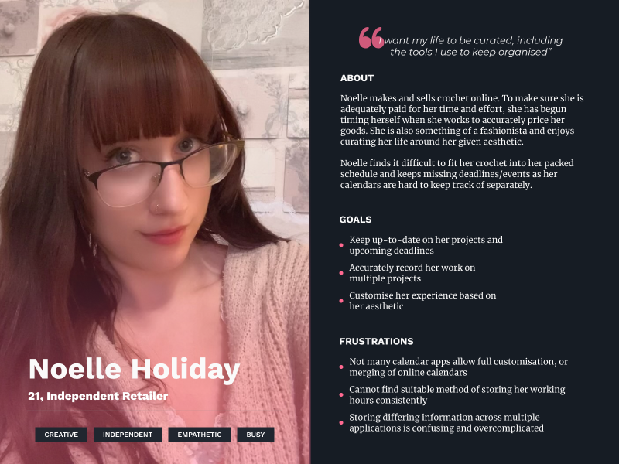
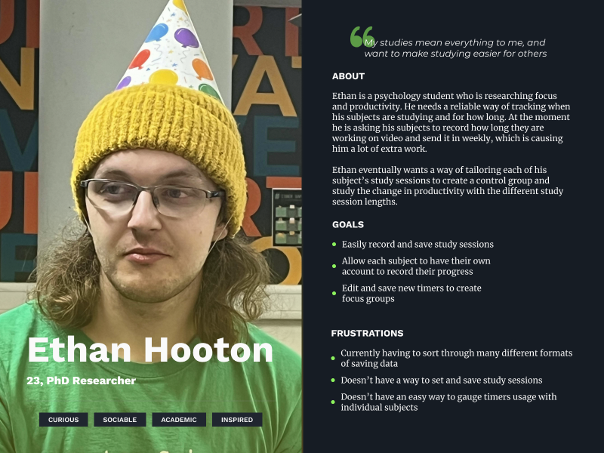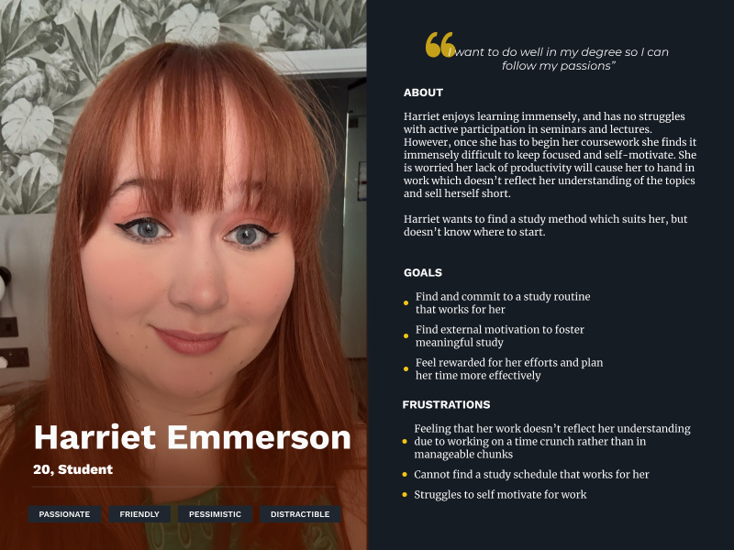
(all photos used with consent of those photographed)

